Advanced Data Visualization Techniques and Best Practices

Data visualization is a critical tool for uncovering insights, supporting decision-making, and communicating findings effectively. In today’s data-driven world, where organizations generate and process vast amounts of information daily, visualizations act as a bridge between raw data and actionable insights. They help in simplifying complex datasets, uncovering hidden trends, and presenting data in a manner that is easy to interpret and impactful. As data complexity grows, advanced techniques are required to transform raw data into actionable intelligence.

The role of advanced visualization extends beyond traditional charts and graphs. It enables the integration of interactivity, geospatial analytics, real-time updates, and multi-dimensional analysis, all of which cater to modern analytical needs. Advanced tools and frameworks now allow data professionals to craft visualizations that are not only informative but also engaging and aesthetically appealing, ensuring that stakeholders can make informed decisions efficiently.

This document provides an in-depth guide to advanced visualization techniques, principles, and examples, ensuring impactful data representation. It emphasizes both the theoretical and practical aspects, offering best practices, actionable insights, and a range of implementation examples. Furthermore, the document includes detailed code snippets and practical implementations using popular tools and libraries, enabling readers to apply the techniques directly to their projects. By the end of this guide, you will have a comprehensive understanding of advanced data visualization and its significance in delivering meaningful results in any domain.

Principles of Effective Data Visualization
To ensure the success of any visualization, it is crucial to follow established principles:

Clarity and Precision:
- Make visualizations easy to understand and avoid clutter by keeping designs minimal and purposeful.

Data-Ink Ratio:
- Focus on maximizing the data-to-ink ratio by removing non-essential elements.

Consistency:
- Maintain uniform styles for axes, colors, and fonts across related visualizations to ensure coherence.

Accessibility:
- Use colourblind-friendly palettes and high-contrast designs.
- Incorporate tooltips and text labels in interactive charts for accessibility.

Avoiding Misleading Representations:
- Use proportional scales and ensure that axis intervals accurately represent data.
- Avoid visual elements like distorted axes or 3D effects that obscure insights.

Advanced Visualization Types

Interactive Visualizations
Interactive visualizations allow users to engage dynamically with the data. These can include hover effects, filtering options, and drill-down capabilities. Libraries like Plotly, Dash, and D3.js enable the creation of such visualizations.
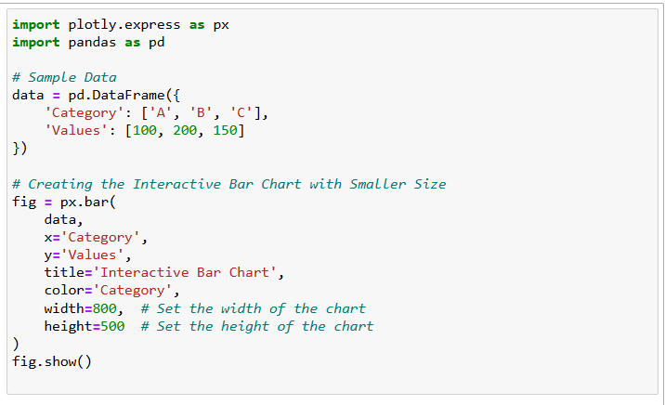

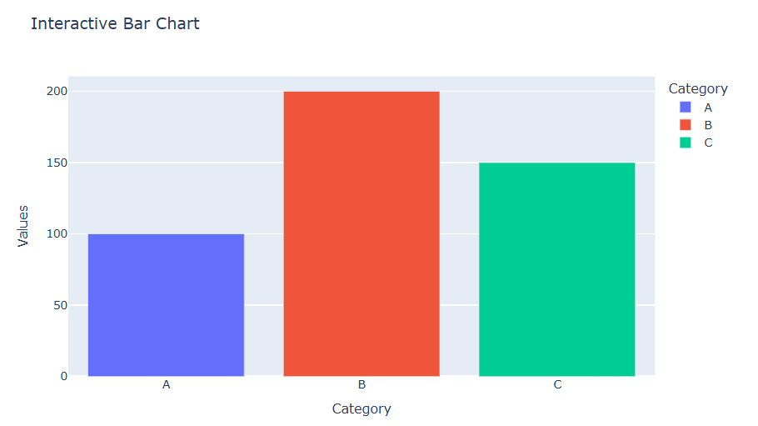

Geospatial Visualizations
Geospatial visualizations are ideal for representing location-based data. Tools like Folium and Kepler.gl are widely used for creating maps and analysing spatial trends.
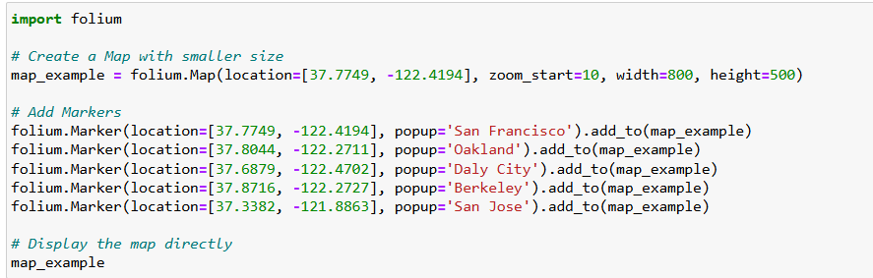
Example: Using Folium to create a map with markers.

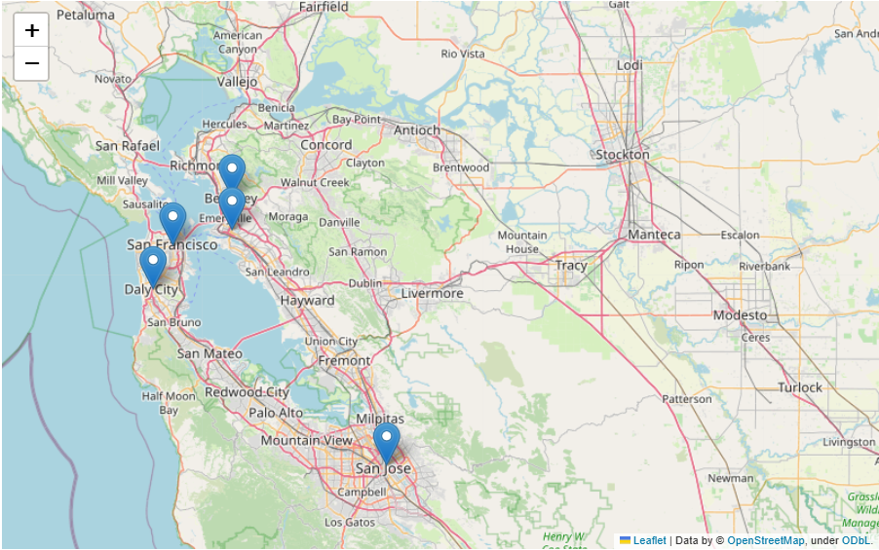

Time-Series Analysis
Time-series visualizations are essential for understanding trends over time. Advanced techniques include using moving averages, forecasting overlays, and annotations.

Example: Plotting time-series data with Matplotlib.
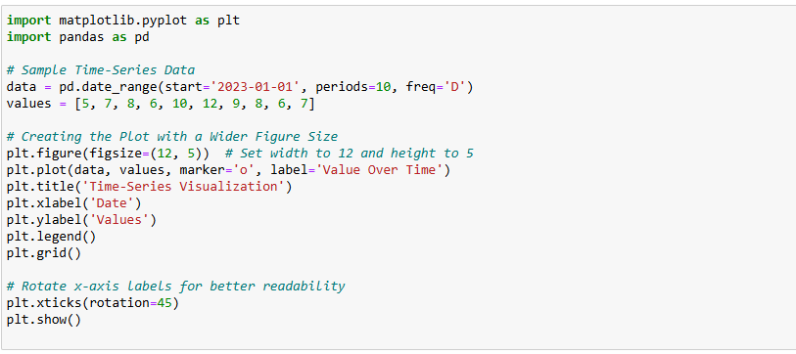

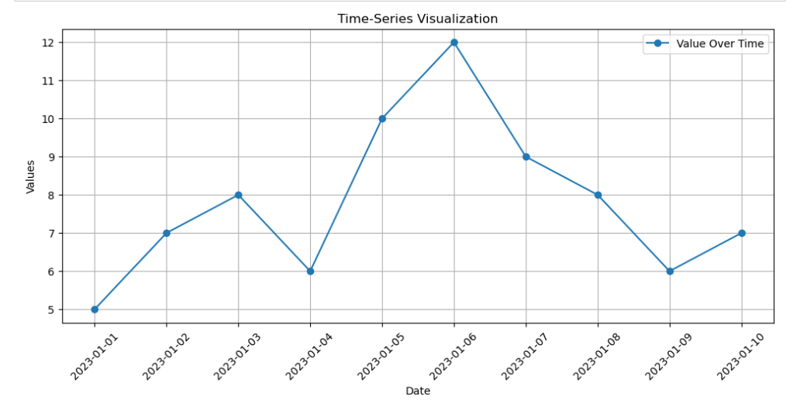

Multi-Dimensional Data Visualization
Techniques like scatter plot matrices, radar charts, and parallel coordinates enable visualization of multi-dimensional datasets.
Example: Using Seaborn to create a scatter plot matrix.
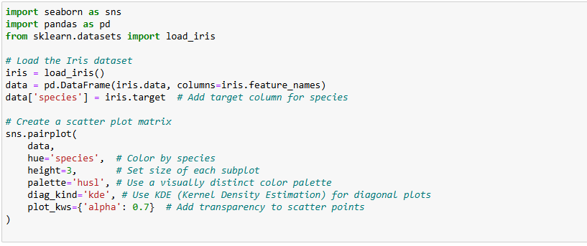

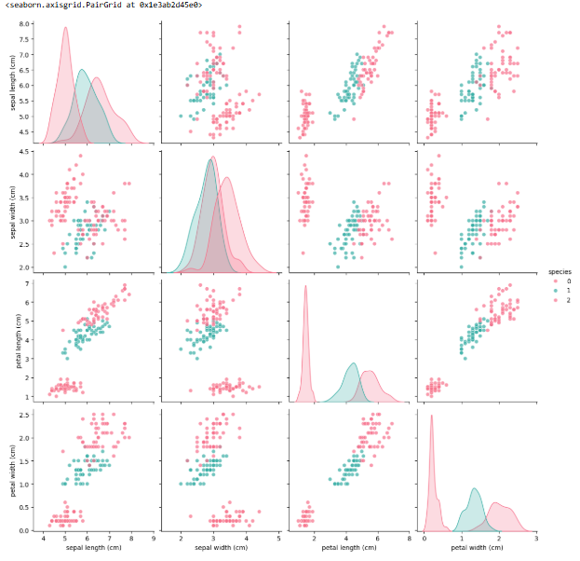

Heatmaps for Correlation Analysis
Heatmaps are an effective way to visualize correlations or patterns within a dataset. They are commonly used in statistical analyses.
Example: Creating a heatmap with Seaborn.
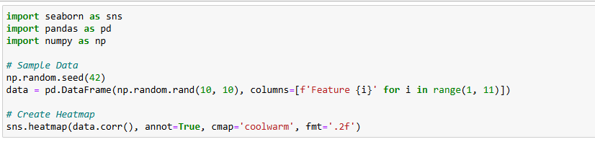

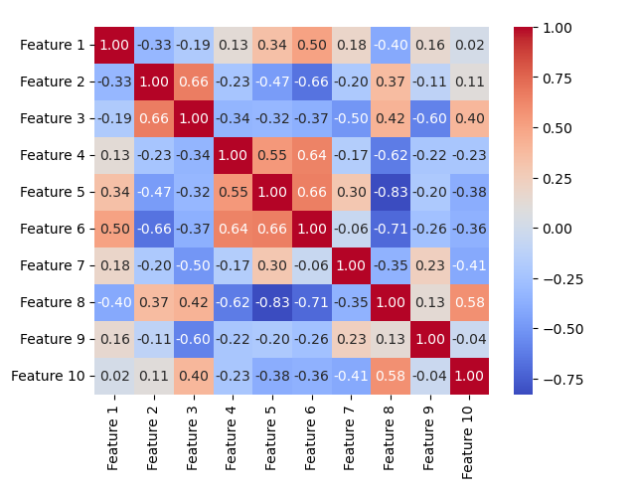

Performance Optimization for Visualization

Handling Large Datasets:
- Use data sampling or aggregation to reduce data points without losing trends.

Server-Side Rendering
- Employ server-side tools to render large-scale visualizations efficiently

Asynchronous Loading
- Load data asynchronously to enhance performance for real-time dashboards.

Example: Downsampling a dataset for visualization.
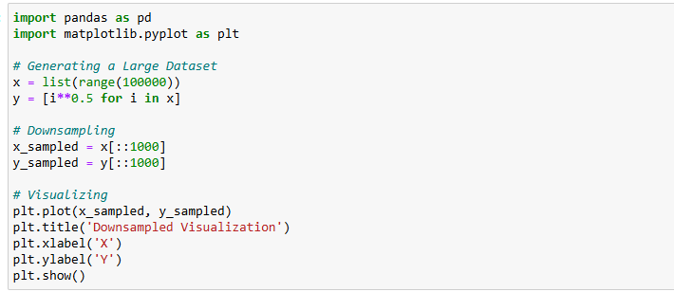

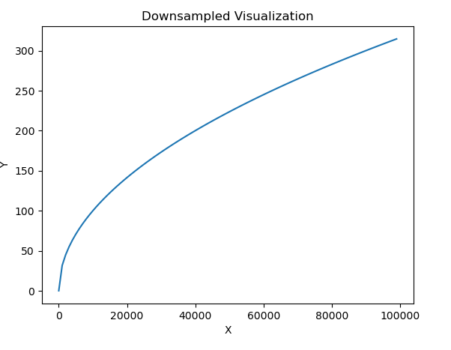

Advanced Case Study: Environmental Data Visualization
Scenario: Advanced analysis of tree canopies, microclimate sensors, and water flow routes to uncover environmental trends in Melbourne.

Objectives:
- Create interactive visualizations for multi-layered environmental data.
- Integrate data sources like real-time microclimate data.
- Enable comparative analysis across zones and time intervals.

Plan:
- Data Preparation:
Standardize and clean data, handling missing/outlier values and aggregate data by time intervals and geographical zones.

- Multi-Layer Visualization:
Bar Charts: Compare tree canopy coverage and water flow across zones.
Line Charts: Show temporal trends for metrics like temperature and humidity.

- Advanced Features:
Filters for zones, time ranges, and metrics.
Hover tooltips for detailed data.
Integration with live microclimate APIs.
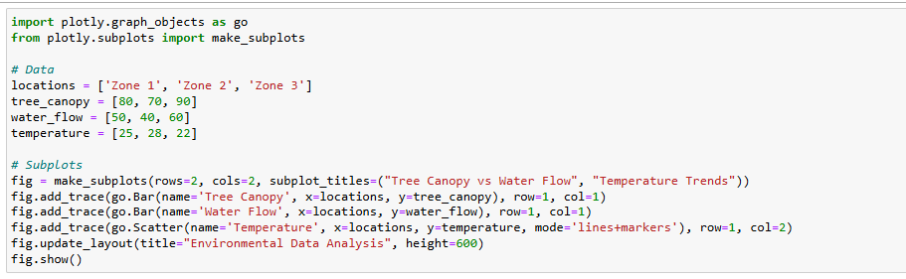
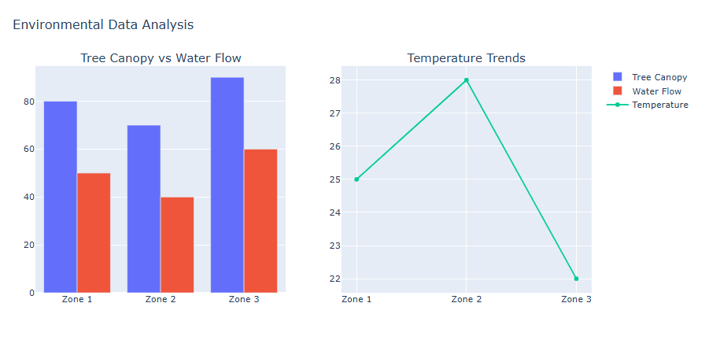

Author
Randi Tamasha Gunasekara. (Created on 12.12.2024)

